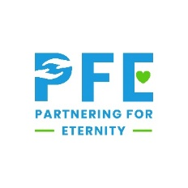
K-8 Commitments
Welcome to the Partnering for Eternity family! We are excited that your child is participating in PFE this year. We hope they will make a difference in the life of their mentor, participate in service activities, and benefit from tuition assistance. To have a successful program year, we need you to be an active participant in the program as well.
Parent/Guardian Commitments
- Support your local PFE team in selecting a great mentor match for your child
  - The mentor cannot be a relative
  - Two students cannot share a mentor
- Attend student/parent orientation each year
- Help your child set up an account on the reporting website
- Schedule and transport your child to and from their weekly visits
- Attend and supervise your child’s weekly visits
- Make sure your child submits a reflection after each visit (within 24 hours)
- Communicate with your local PFE coordinator about any concerns or challenges
- Help your child complete any surveys or questionnaires from PFE Administration

Being able to make these commitments is crucial to your child participating in and getting the most out of PFE. If you are unable to commit, your child may need to be removed from the program.

______I understand that my student’s participation in this program is voluntary.
______I understand that my student must complete both the visit and the reflection (within the deadline) to receive PFE assistance.
______I understand that if my student doesn’t fulfill the requirements of the program, I will be financially obligated to pay the PFE amount personally.
*Parent/guardian initial by each statement

My signature below indicates that I have read this document and agree to be bound by the terms of it.

Parent Name________________________________ Parent Signature_____________________________
Student Name_______________________________ Student Signature___________________________
Mentor Name_______________________________ Mentor Signature____________________________

